IUMS 2020 Daejeon, Korea - Virtual Congresses

16th International Congress of Bacteriology & Applied Microbiology
16th International Congress of Mycology & Eukaryotic Microbiology
18th International Congress of Virology
FKMS 2020
Dear fellow microbiologists and colleagues,
On behalf of the National Organizing Committee and the Federation of Korean Microbiological Societies (FKMS), I would like to welcome the delegates from all over the world to the IUMS 2020 Daejeon, Korea - Virtual Congresses which will take place 16 – 20 November, 2020 in Daejeon, Korea. Being the hub of advanced science and technology in Korea with its modern infrastructure and beautiful surroundings, Daejeon is truly an ideal venue for the IUMS 2020 Daejeon, Korea - Virtual Congresses.
IUMS 2020 Daejeon, Korea - Virtual Congresses, Korea incorporates three major international congresses: the 16th International Congress of Bacteriology and Applied Microbiology, the 16th International Congress of Mycology and Eukaryotic Microbiology and the 18th International Congress of Virology. These separate congresses will be connecting each other with all current issues and different topics of microbiology in the Bridging Sessions.
This event will be truly an international arena for the exchange of knowledge and ideas among professionals from academia, clinical practice, industry and research institutions to foster cross-discipline collaboration in the spirit of sharing. The knowledge, information and experience will be shared by participants to make the events the largest and most comprehensive gathering of global microbiological community.
We are ready and in good preparation to host the most successful IUMS 2020 Daejeon, Korea - Virtual Congresses, having acquired the full supports of related institutions which include Korea’s Central and Daejeon Metropolitan City Governments, all of 5 member societies of FKMS, academia and companies in the private sector.
With a great pride and excitement, I am very much looking forward to meeting all the delegates with memorable and scientifically stimulating congresses. I wish all of you to come and enjoy great time and have wonderful experiences in the IUMS 2020 Daejeon, Korea - Virtual Congresses.

Yours sincerely,
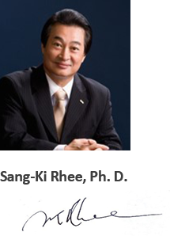
Chairman
National Organizing Committee
IUMS 2020 Daejeon, Korea Continues to the next chapter→

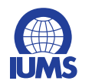
International Union of Microbiological Societies

- International Congress of Bacteriology & Applied Microbiology(BAM)
- International Congress of Mycology & Eukaryotic Microbiology(MEM)
- International Congress of Virology(VIR)
IUMS is one of the 31 Scientific Unions of the International Council of Science(ICSU). The major goal of IUMS is to promote research and the open exchange of scientific information for advancement of the health and welfare of humankind and the environment and strongly discourages any uses of knowledge and resources to the contrary.
The major activities of IUMS include the classification and nomenclature of bacteria, fungi and viruses, food microbiology, medical microbiology and diagnostics, culture collections, education, and biological standardization. IUMS holds the international congresses every 3 years; International Congress of Bacteriology & Applied Microbiology(BAM), International
Congress of Mycology & Eukaryotic Microbiology(MEM) and International Congress of Virology(VIR).

FEDERATION OF KOREAN MICROBIOLOGICAL SOCIETIES

The Federation of Korean Microbiological Societies (FKMS) is the representative academic society for microbiology in Korea. FKMS was founded on June 16, 2000 by the Korean Society of Mycology, the Microbiological Society of Korea, the Korean
Society for Microbiology and Biotechnology, and the Korean Society of Virology for the development of microbiology in Korea and the advancement of academic competence and international cooperation.

The Federation of Korean Microbiological Societies is comprised of four member societies:
▶ The Korean Society for Microbiology and Biotechnology
▶ The Korean Society of Virology
▶ The Korean Society of Mycology
▶ The Microbiological Society of Korea

Continues to the next chapter→

- Overview
▶ Title: IUMS 2020 Daejeon, Korea - Virtual Congresses
▶ Theme: IUMS2020 for Harmonious Diversity
▶ Date: 16(Mon) ~20 (Fri) November 2020
▶ Venue: Daejeon Convention Complex
▶ City: Daejeon Metropolitan City of Korea
▶ Organizers: International Union of Microbiological Societies (IUMS)
The Federation of Korean Microbiological Societies (FKMS)

- Important Dates
▶ 2nd Abstract Submission Deadline: 5 (Mon) Oct 2020
▶ 1st Virtual Registration Deadline: 23 (Fri) Oct 2020
▶ 2nd Virtual Registration Deadline: 20 (Fri) Oct 2020

- Registration Dates
1st Virtual Registration | 2nd Virtual Registration
By 23(Fri) October 2020 | 20 (Fri) November 2020

Category |  | 1st Virtual Registration  (By 23(Fri) October 2020) | 2nd Virtual Registration  (20 (Fri) November 2020)
Full Congresses Access | Participant | USD 300 | USD 600
 | Student & Postdoc | USD 150 | USD 300
General Participation |  | Free
- Registration Fee

- Pre-registration procedure
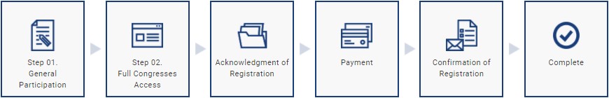
* The general participation is free of charge only for some lectures, such as Nobel lecture and COVID-19 special sessions, etc.

- Entitlements for each registration category
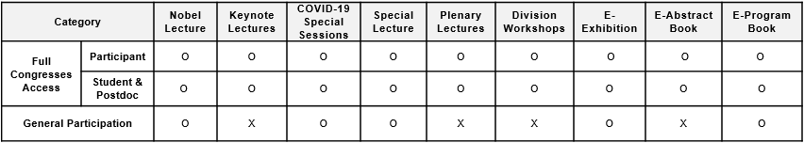

Continues to the next chapter→

- Registration Contact
Secretariat of IUMS 2020 Daejeon, Korea
Tel: +82-70-4711-3211
Fax: +82-2-325-1720
Email: iums2020_reg@pod-pco.com

